SmartSDLC – AI-Enhanced Software Development Lifecycle

1. Introduction
Project Title: SmartSDLC – AI-Enhanced Software Development Lifecycle
Team Members:
- DINESHKUMAR A
- PANDIDURAI E
- DEEPAK V
- DHIVYANATHAN M

2. Project Overview

Purpose
The purpose of SmartSDLC is to enhance the traditional Software Development Lifecycle (SDLC) by integrating AI-driven automation, forecasting, and analytics. The project demonstrates how an AI-augmented system can improve decision-making, optimize resources, and reduce risks in software development.

Features
• Conversational Interface: Natural language interaction for requirements, queries, and assistance.
• Policy / Document Summarization: Converts lengthy docs into concise summaries.
• Resource Forecasting: Predicts effort, time, and resource usage at each phase.
• AI-Assisted Code & Testing: Auto-generates code snippets, test cases, and bug predictions.
• KPI Tracking & Forecasting: Monitors project progress and forecasts KPIs.
• Anomaly Detection: Identifies unusual patterns in project metrics.
• Stakeholder Feedback Loop: Collects feedback to refine requirements.
• Multimodal Input Support: Accepts text, PDFs, and CSVs for document analysis.
• Streamlit/Gradio UI: User-friendly dashboards for project teams.

3. Architecture
- Frontend (Streamlit/Gradio): Interactive web UI with dashboards, chat interface, and KPI visualizations.
- Backend (FastAPI): RESTful API endpoints for docs, reports, and embeddings.
- LLM Integration (IBM Watsonx Granite): Summarization, recommendations, and assistance.
- Vector Search (Pinecone): Semantic search for project knowledge base.
ML Modules: Forecasting and anomaly detection for project KPIs.

4. Setup Instructions

Prerequisites
• Python 3.9+
• pip & venv tools
• API keys for IBM Watsonx & Pinecone
• Internet access

Installation
1. Clone repository
2. Install dependencies (requirements.txt)
3. Configure .env with credentials
4. Run FastAPI backend server
5. Launch Streamlit frontend
6. Upload docs/CSVs and interact

5. Folder Structure
app/ – FastAPI backend
└── api/ – API routes (chat, feedback, reports)
ui/ – Streamlit frontend
smart_dashboard.py – Main Streamlit dashboard
granite_llm.py – LLM communication
document_embedder.py – Embeddings + Pinecone
kpi_file_forecaster.py – Forecasting module
anomaly_file_checker.py – Anomaly detection
report_generator.py – AI-generated reports

6. Running the Application
1. Start FastAPI server
2. Run Streamlit dashboard
3. Navigate pages
4. Upload files and interact
5. View outputs: reports, summaries, forecasts, anomaly alerts

7. API Documentation
• POST /chat/ask – Query assistant
• POST /upload-doc – Upload & embed documents
• GET /search-docs – Semantic search
• GET /get-eco-tips – Sustainability/coding tips
• POST /submit-feedback – Store feedback

8. Authentication
Current demo: open access.
Future options:
• JWT / API keys
• OAuth2 (IBM Cloud)
• Role-based access

9. User Interface
• Sidebar navigation
• KPI visualization cards
• Tabs for chat, forecasts, and reports
• Real-time input forms
• PDF report downloads

10. Testing
• Unit Testing: Utility scripts, ML models
• API Testing: Swagger UI & Postman
• Manual Testing: File uploads, chat responses
• Edge Cases: Invalid keys, large files

11. Screenshots

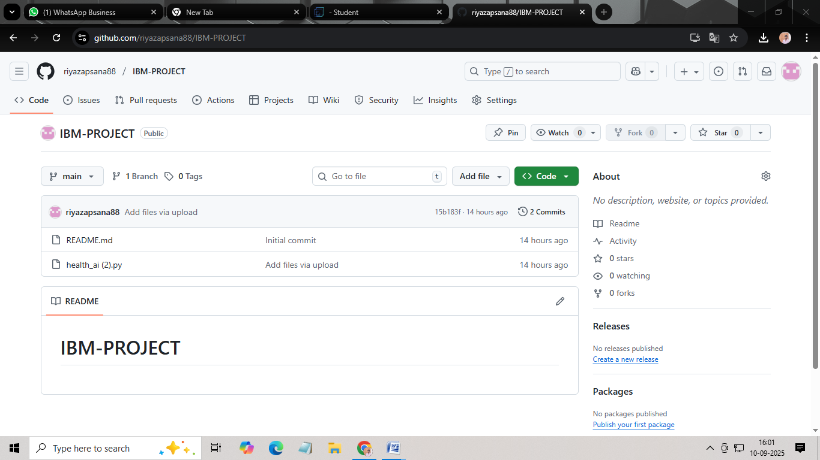
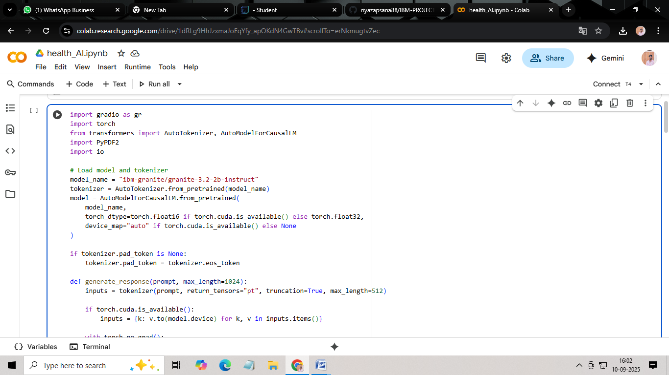

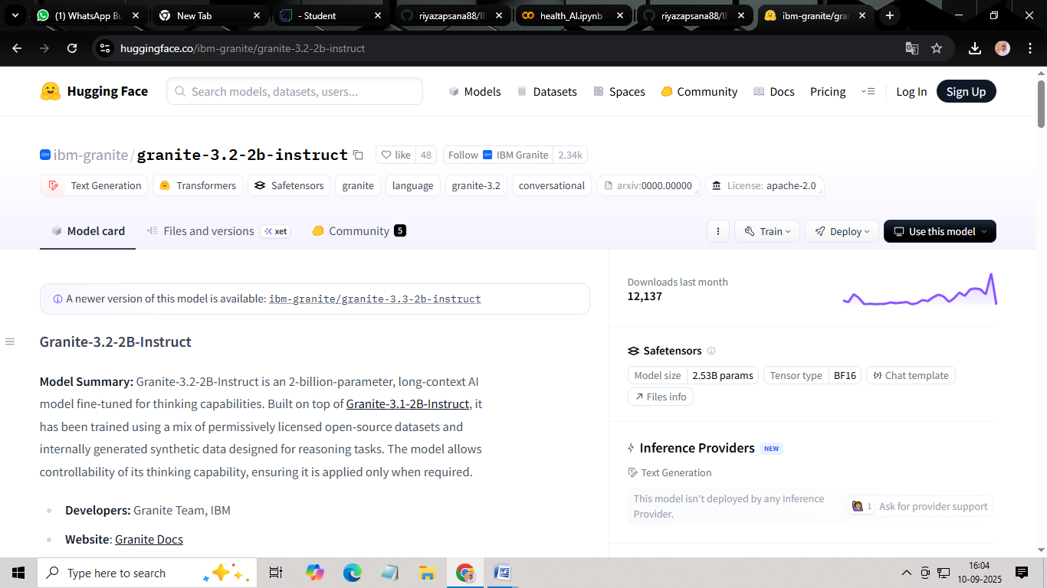
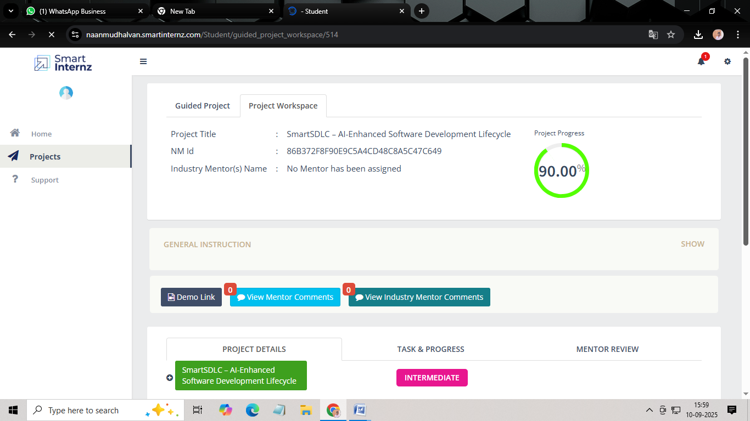

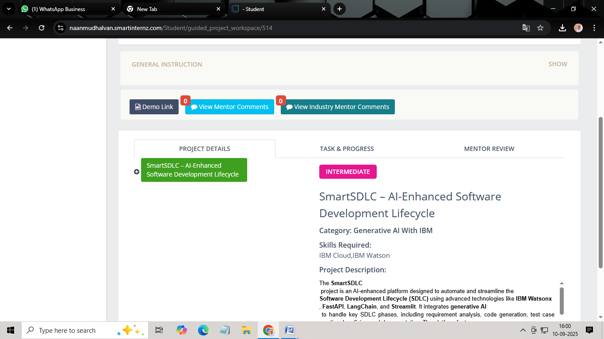

12. Known Issues
• Limited offline functionality
• Dependency on external APIs
• Scalability challenges

13. Future Enhancements
• CI/CD pipeline integration
• Multi-language support
• Advanced role-based dashboards
• Expanded anomaly detection
• Auto-document generation

